DAA Lab Assignment
Roll no. – 2401730237
Name – Dev Yadav
Class – Ai & Ml section C
Q1 Fractional knapsack
Code-
#include <iostream>
#include <vector>
#include <algorithm>
using namespace std;

struct Item {
double value, weight;
};

// Comparator: sort by value/weight ratio descending
bool cmp(Item a, Item b) {
return (a.value / a.weight) > (b.value / b.weight);
}

double fractionalKnapsack(double capacity, vector<Item>& items) {
sort(items.begin(), items.end(), cmp);

double totalValue = 0.0;

for (auto& item : items) {
if (capacity == 0) break;

if (item.weight <= capacity) {
// Take the whole item
totalValue += item.value;
capacity -= item.weight;
} else {
// Take a fraction
double fraction = capacity / item.weight;
totalValue += item.value * fraction;
capacity = 0;
}
}
return totalValue;
}

int main() {
double capacity = 50;
vector<Item> items = {{60,10}, {100,20}, {120,30}};

cout << "Max value: " << fractionalKnapsack(capacity, items) << endl;
// Output: Max value: 240
cout <<"name - dev , roll no - 2401730237"<<endl;
return 0;
}

Output
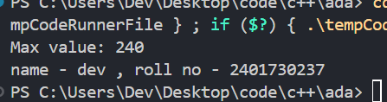

Q2 Matrix Chain Multiplication
Code-
#include <iostream>
#include <vector>
#include <climits>
using namespace std;

void printOptimalParens(vector<vector<int>>& bracket, int i, int j) {
if (i == j) { cout << "M" << i+1; return; }
cout << "(";
printOptimalParens(bracket, i, bracket[i][j]);
printOptimalParens(bracket, bracket[i][j]+1, j);
cout << ")";
}

int matrixChainOrder(vector<int>& dims) {
int n = dims.size() - 1; // number of matrices
vector<vector<int>> dp(n, vector<int>(n, 0));
vector<vector<int>> bracket(n, vector<int>(n, 0));

// chain_len = length of chain being considered
for (int len = 2; len <= n; len++) {
for (int i = 0; i <= n - len; i++) {
int j = i + len - 1;
dp[i][j] = INT_MAX;

for (int k = i; k < j; k++) {
int cost = dp[i][k] + dp[k+1][j]
+ dims[i] * dims[k+1] * dims[j+1];
if (cost < dp[i][j]) {
dp[i][j] = cost;
bracket[i][j] = k;
}
}
}
}

cout << "Optimal parenthesization: ";
printOptimalParens(bracket, 0, n-1);
cout << endl;

return dp[0][n-1];
}

int main() {
// Matrices: 10x30, 30x5, 5x60, 60x10
vector<int> dims = {10, 30, 5, 60, 10};
cout << "Min multiplications: " << matrixChainOrder(dims) << endl;
// Output: Min multiplications: 27000
cout <<"name - dev , roll no - 2401730237"<<endl;
return 0;
}

Output-
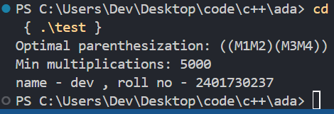

Q3 Longest Common Subsequence( LCS )
Code-
#include <iostream>
#include <vector>
#include <string>
#include <algorithm>
using namespace std;

pair<int, string> lcs(const string& s1, const string& s2) {
int m = s1.size(), n = s2.size();
vector<vector<int>> dp(m+1, vector<int>(n+1, 0));

for (int i = 1; i <= m; i++) {
for (int j = 1; j <= n; j++) {
if (s1[i-1] == s2[j-1])
dp[i][j] = dp[i-1][j-1] + 1;
else
dp[i][j] = max(dp[i-1][j], dp[i][j-1]);
}
}

string result = "";
int i = m, j = n;
while (i > 0 && j > 0) {
if (s1[i-1] == s2[j-1]) {
result += s1[i-1];
i--; j--;
} else if (dp[i-1][j] > dp[i][j-1]) {
i--;
} else {
j--;
}
}

reverse(result.begin(), result.end());
return make_pair(dp[m][n], result);
}

int main() {
string s1 = "ABCBDAB";
string s2 = "BDCAB";

pair<int, string> result = lcs(s1, s2);
cout << "LCS Length : " << result.first << endl;
cout << "LCS Sequence : " << result.second << endl;
// Output: LCS Length : 4
// LCS Sequence : BCAB
cout<< "name - dev , roll no - 2401730237"<<endl;
return 0;
}

Output-
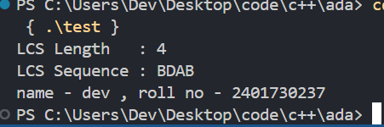

Q4 0/1 knapsack
Code-
#include <iostream>
#include <vector>
#include <algorithm>
using namespace std;

pair<int, vector<int>> knapsack01(int capacity,
vector<int>& weights,
vector<int>& values) {
int n = weights.size();
vector<vector<int>> dp(n+1, vector<int>(capacity+1, 0));

for (int i = 1; i <= n; i++) {
for (int w = 0; w <= capacity; w++) {
dp[i][w] = dp[i-1][w];
if (weights[i-1] <= w) {
int take = dp[i-1][w - weights[i-1]] + values[i-1];
dp[i][w] = max(dp[i][w], take);
}
}
}

vector<int> selected;
int w = capacity;
for (int i = n; i > 0; i--) {
if (dp[i][w] != dp[i-1][w]) {
selected.push_back(i-1);
w -= weights[i-1];
}
}
reverse(selected.begin(), selected.end());
return make_pair(dp[n][capacity], selected);
}

int main() {
int capacity = 50;
vector<int> weights = {10, 20, 30};
vector<int> values = {60, 100, 120};

pair<int, vector<int>> res = knapsack01(capacity, weights, values);
int maxVal = res.first;
vector<int> items = res.second;

cout << "Max value: " << maxVal << endl;
cout << "Items (0-based): ";
for (int i : items) cout << i << " ";
cout << endl;
// Output: Max value: 220
// Items: 1 2
cout <<"name - dev , roll no - 2401730237"<<endl;
return 0;
}

Output-
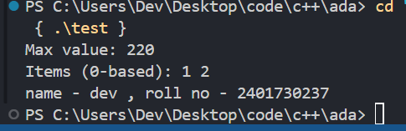
Q5 Dijksatras Algorithm
Code-
#include <iostream>
#include <vector>
#include <queue>
#include <climits>
using namespace std;

typedef pair<int,int> pii;

vector<int> dijkstra(int src, int V, vector<vector<pii>>& graph) {
vector<int> dist(V, INT_MAX);
dist[src] = 0;

priority_queue<pii, vector<pii>, greater<pii>> pq;
pq.push(make_pair(0, src));

while (!pq.empty()) {
int d = pq.top().first;
int u = pq.top().second;
pq.pop();

if (d > dist[u]) continue;

for (int i = 0; i < graph[u].size(); i++) {
int v = graph[u][i].first;
int w = graph[u][i].second;
if (dist[u] + w < dist[v]) {
dist[v] = dist[u] + w;
pq.push(make_pair(dist[v], v));
}
}
}
return dist;
}

int main() {
int V = 5;
vector<vector<pii>> graph(V);
graph[0].push_back(make_pair(1, 4));
graph[0].push_back(make_pair(2, 2));
graph[1].push_back(make_pair(3, 3));
graph[1].push_back(make_pair(2, 5));
graph[2].push_back(make_pair(1, 1));
graph[2].push_back(make_pair(3, 8));
graph[2].push_back(make_pair(4, 10));
graph[3].push_back(make_pair(4, 2));

vector<int> dist = dijkstra(0, V, graph);

cout << "Shortest distances from node 0:" << endl;
for (int i = 0; i < V; i++)
cout << " to " << i << " = " << dist[i] << endl;
// Output: 0->0=0, 0->1=3, 0->2=2, 0->3=6, 0->4=8
cout <<"name - dev , roll no - 2401730237"<<endl;
return 0;
}

Output-
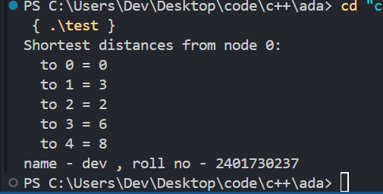

Q6 Bellman-Forman Algorithm
Code-
#include <iostream>
#include <vector>
#include <climits>
using namespace std;

struct Edge {
int u, v, w;
};

vector<int> bellmanFord(int src, int V, vector<Edge>& edges) {
vector<int> dist(V, INT_MAX);
dist[src] = 0;

// Relax all edges V-1 times
for (int i = 0; i < V - 1; i++) {
bool updated = false;
for (int j = 0; j < edges.size(); j++) {
int u = edges[j].u;
int v = edges[j].v;
int w = edges[j].w;
if (dist[u] != INT_MAX && dist[u] + w < dist[v]) {
dist[v] = dist[u] + w;
updated = true;
}
}
if (!updated) break;
}

// Detect negative-weight cycles
for (int j = 0; j < edges.size(); j++) {
int u = edges[j].u;
int v = edges[j].v;
int w = edges[j].w;
if (dist[u] != INT_MAX && dist[u] + w < dist[v]) {
cout << "Negative cycle detected!" << endl;
return {};
}
}

return dist;
}

int main() {
int V = 5;
vector<Edge> edges;

edges.push_back({0, 1, 6});
edges.push_back({0, 3, 7});
edges.push_back({1, 2, 5});
edges.push_back({1, 3, 8});
edges.push_back({1, 4, -4});
edges.push_back({2, 1, -2});
edges.push_back({3, 2, -3});
edges.push_back({3, 4, 9});
edges.push_back({4, 0, 2});
edges.push_back({4, 2, 7});

vector<int> dist = bellmanFord(0, V, edges);

cout << "Shortest distances from node 0:" << endl;
for (int i = 0; i < V; i++)
cout << " to " << i << " = " << dist[i] << endl;
// Output: to 0=0, to 1=2, to 2=4, to 3=7, to 4=-2
cout <<"name - dev , roll no - 2401730237"<<endl;
return 0;
}

Output-
